**ALICE: Automatic Localization of Intra-Cranial Electrodes**

*Written by Mariana P. Branco and Anna Gaglianese*

*(contact: m.pedrosobranco@umcutrecht.nl)*

1. **How to install ALICE?**

**1.1** The 3D-CTMR was primarily developed in a Linux platform. If you are also using a linux platform be sure to had the following path to your .*bashrc*.

You can open your *.bashrc* by typing kate ~/.bashrc in the terminal. Kate is an editor program.

Add the following lines (in blue) after the last **export/source** lines inside the **if [“$P1”]** branch:

**if [ "$PS1" ]; then**

**…**

#New AFNI path december 2016

#where AFNI is installed, e.g.:

AFNI_INSTALLDIR=/Scratch/AFNI/afni_2016-12-02/linux_fedora_21_64

# add the AFNI binary path to the search path

PATH=${AFNI_INSTALLDIR}:${PATH}

# Location of the plugins

AFNI_PLUGINPATH=${AFNI_INSTALLDIR}

# Location of the timseries models (also plugins)

AFNI_MODELPATH=${AFNI_INSTALLDIR}

# Location of the talairach daemon database

AFNI_TTATLAS_DATASET=/usr/share/afni/atlases

# Suppress warning for missing mpeg output

AFNI_IMSAVE_WARNINGS=NO

export PATH AFNI_PLUGINPATH AFNI_MODELPATH AFNI_IMSAVE_WARNINGS AFNI_TTATLAS_DATASET

# set PATH so it includes user's private bin if it exists

if [ -d ~/bin ] ; then

PATH=~/bin:"${PATH}"

fi

**fi**

**Save** the *.bashrc* file. **Close** the editor program and the terminal window. In a **new** terminal do suma –update_env .

* 1. Open MATLAB (version more recent than 2015a).
  2. Update your Juniper m-files/CTMR folder. The content of this folder was recently changed. So if you are updating for the **first time** the ALICE, please delete the CTMR folder before updating your SVN. A new CTMR folder will appear with the newest code.
  3. Add the Juniper/m-files/CTMR to your path using addpath(‘’). And verify that SPM12 is in your MATLAB path too.

**2. Prepare input files**

Before starting running the program be sure to have the necessary input files. The CTMR procedure requires 3 input files: the CT, the T1 anatomy (from FreeSurfer) and the Freesurfer segmentation. Be sure to convert the CT and FreeSurfer ribbon to *.nii format (use Step 2.1 to 2.3 if necessary).

For most recent patients, these files can be found in the patient folder in the following folders:

* MRI (T1.nii): mrdata/FreeSurfer/mri/T1.nii
* FreeSurfer (t1_class.nii): mrdata/FreeSurfer/mri/ribbon.mgz
* CT (CT_highres.nii): CTscan/rawCT/*

|  |
| --- |
| **2.1 Convert CT from dicom (*.dcm) to *.nii format:**  On the /dicom folder call dcm2nii –c N . on the terminal.  Or use via Menu > Applications > Education > dcm2nii to use the GUI.  Rename the file using the terminal command:  3dcopy Date_code.nii.gz ../coregistration/CT_highres.nii  **2.2 Convert CT from *.img/hdr to *.nii format:**  If you are using img/hdr format please verify in SPM that the voxel size is correct and according to the respective *.ics file.  In the terminal use the command:  mri_convert name.hdr CT_highres.nii  **2.3 Convert Freesurfer ribbon.mgz to *.nii:**  Be sure to have FreeSurfer in our bash (see **Note**). In the terminal call:  mri_convert ribbon.mgz t1_class.nii |

|  |
| --- |
| **Note:** |
| To run mri_convert. First, add FreeSurfer to your bashrc. In the terminal do:    >> kate ~/.bashrc  Add to your bachrc:  export FREESURFER_HOME=/usr/local/freesurfer  source $FREESURFER_HOME/SetUpFreeSurfer.sh |

**3. Overview of the user interface**

Locate MATLAB current directory to the folder where you wish the program to save the output files (use *subject_name/analysed/*). Be sure to have writing permissions in that folder.

Start the ALICE program by typing ‘alice’ in the command window of MATLAB:

>> alice

The following window with open:

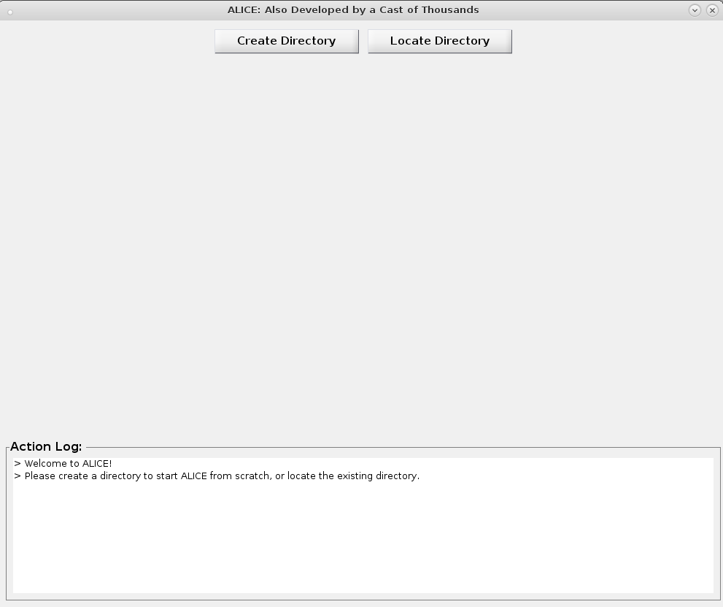

Now you are ready to start the CTMR procedure.

**Please** **report any errors**.

**4. Start the CTMR procedure:**

You can follow the instructions in the **ACTION LOG**.

**The first step in the pipeline is to create a folder were all the input and output files will be stored, labeled and logged.**

**When you start the program two buttons appear on the top (see figure above). Choose to:**

1. **Create a folder:** If you are starting the program for the first time for a given subject, choose CREATE DIRECTORY. The program will create a new directory where the important files are stored. When necessary the program will also copy functions to the respective folders.
2. **Or Locate an existing one:** If you have previously created a folder *using this pipeline*, interrupted the pipeline and now wish to proceed with the program, choose LOCATE DIRECTORY. When loading a directory, the program will automatically recognize the source files and display the path on the interface. No need to load the files again.

|  |
| --- |
| * 3Dclustering * data * coregistration * CT * projected_electrodes_coord * Freesurfer * MRI * log_info * results |

The original files, renamed, will be copied to the corresponding folders. Please do not copy or move the files yourself, strictly use the interface to locate & copy the (source) files.

All steps that you perform will be logged inside **./log_info** in three separate files for the three procedural steps.

**Now, follow the three steps indicated in the interface:**

**1)** **STEP 1:** **Locate the input files (if not yet loaded with LOCATE DIRECTORY).**

Use the ‘Open’ buttons to locate the source files (T1, FreeSurfer ribbon and CT). These will be copied, renamed and moved to the ALICE folder.

Align the CT to the MRI by selecting ‘Align CT to MRI’. This function will take some time. Be patient.

Once the alignment finishes, AFNI will open and a help message will be displayed with some instructions. AFNI will automatically set the T1 as underlay and the CT as overlay. **If that is not the case, please contact us.**

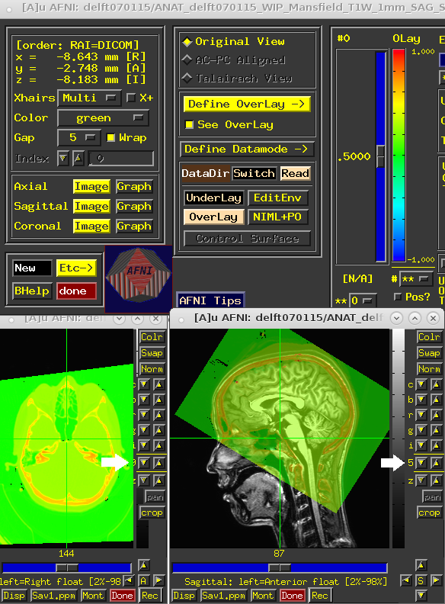To change the transparency of the CT layer use the ‘9’ up-down buttons on the slices view (see figure below, white arrow). Scroll through the slices using the scrolling bar on the button of each view-window.

If the alignment is good, please close AFNI and proceed to step 2.

NOTE: on a remote NoMachine trial, "opengl defaults to software" message may appeared at this point. Hardware version should be faster, so please use opengl("save","hardware").

**2)** **STEP 2:** **Extract the electrode clusters and centers-of-mass.**

The original CT (loaded in step 1) will be displayed on the top of Step 2.

Below you can specify three parameters for the extraction of the clusters from the CT:

* Electrode maximum intensity. This value is used to threshold the CT scan in order to cluster volumes above the value. This value will be automatically predicted form the CT file. Please feel free to change this value if the estimated one is too high.
* Electrode volume. This value is a measure of cluster volume. Typically, 3 works for clinical and high-density electrodes.
* Interelectrode space. This value is a measure of distance between the clusters. The value 1 is used as standard, however in some difficult cases (many overlapping electrodes or small high-density grids) 0 might work better.

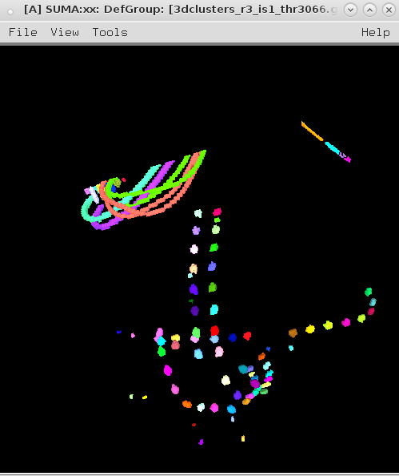Select the ‘Extract Clusters’ button. This function may time some time. Be patient.

Once extracted, SUMA will open. Please check the result in the SUMA interface by using the left-mouse click to rotate, mouse-scroll to zoom in and out, and scroll-lock to pan.

If you see all electrodes well defined by clusters, close SUMA and proceed to the next step. Otherwise, repeat procedure with other parameters.

**3)** **Step 2: Select the electrodes.**

It’s time to select the electrodes using the leads layout (electrode layout). Knowing the electrode order and the grid relative position, as described intraoperatively, locate each electrode in SUMA and select the electrodes one-by-one. Below you see an example of one subject implanted with of three grids (C, IHH and IHL), which are recorded in the channels 1 to 16, 17 to 24 and 33 to 64, respectively.

|  |  |
| --- | --- |
| Screen Clipping |  |
| **Electrode grid relative position and label.** | **Leads order per electrode indicated in the ‘channels’ column.** |

Having this information at hand is very important.

Select the button ‘**Select Electrodes’**. At this point, three programs will be displayed: AFNI, SUMA and a small Matlab interface (see right panel below). If you do not see one of the interfaces please check AFNI and SUMA are in the bash and if you are using the latest version of all the software, or contact us. A message dialog will also be prompt to help guide you through the selection process. Read the instructions in the **message dialog** for more information about the interfaces. When read, please press ‘**OK’**.

**We recommend you to organize the screens in the easiest way for you. AFNI main interface and SUMA object controller can be minimized. See a suggestion in the left panel below.**

|  |  |
| --- | --- |
|  |  |

Use SUMA to select the clusters, using the right mouse click. AFNI jumps to the correct volume position. Navigate in AFNI using the left mouse click.

Use the **‘Select Electrodes’** window to select the electrodes. Here you can see the current electrode number to be selected.

**For each electrode you have the options:**

1. ‘**Select electrode’:** Select a cluster in SUMA (right-mouse click) and then push the button ‘Select electrode’. ‘Select electrode: X’ string on the top of the interface will update accordingly. **The selected electrode will become white**. Please note that usually clinical grids have a marker (smaller) electrode between the first two electrodes of the grid. This makes it easier to identify where to start counting.
2. **‘Go to electrode’:** Sometimes there are channels without ECoG electrodes (see patient example above between channel 25 and 32). In that case, you can choose to go to a specific number (33) using the ‘Go to electrode’fieldand select enter **‘>>’.** You can also choose to redo specific electrodes by using the same field.
3. **‘Set sphere’:** Sometimes a cluster may be missing or may embody two electrodes. Then use the AFNI volume interface to locate the electrode center-of-mass (left-mouse click to select a voxel) and use the button ‘Set Sphere’to create a new cluster around that point.
4. **‘Quit’:** When done, select ‘Quit’. Be patient and **wait until the program closes all windows**.

**4) Step 3: Project the electrodes.**

Project electrodes using the **Method 1** for **clinical grids** and **Method HD** for high-density grids.

|  |  |
| --- | --- |
|  | **Method 1 (Hermes et al. 2010):**  Enter the subject **name** and choose the **hemisphere** where the grids were implanted.  Add grid information necessary to the orthogonal projection method (Hermes et al. 2010).  Per grid insert the grid label (‘**C**’), the electrodes (cluster number) to which it corresponds (**[33:64]**) and the grid size (**4 x 8**). Select **‘Add Grid’** to add the grid information.  Use the **Action Log** to check which grids were added or deleted.  If you make a mistake you can remove the information add by clicking **‘Delete previous grid’.**  Press ‘**Visualize!’** to project the electrodes and see the result. You will see the projection figures and the final result popping-up. |
|  | **Method HD (no projection, just display):**  This method allows displaying the electrode on the surface assuming the distance from the electrode to the cortical surface to be small (Kubanek and Schalk 2015).  Press ‘**Visualize!’** to project the electrodes and see the result.  Two figures show the result before and after being displayed on the surface. |

The **OUTPUT FILES** are saved in the folder **results/projected_electrodes_coord or results_HD/projected_electrodes_coord**, respectively.